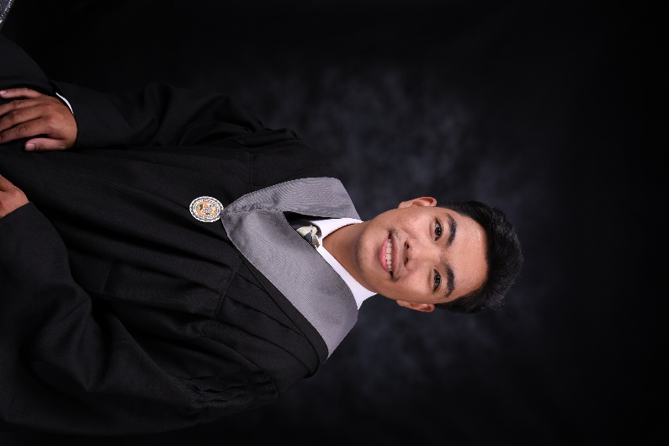
Neil Patrick G. Acierto
Home Address: 137 San Pablo Magalang, Pampanga
Contact Number: 09204756753
Email Address: neilpatrickacierto27@gmail.com

OBJECTIVES

- Cultivate a collaborative team environment by actively sharing expertise and best practices, fostering a culture of continuous learning and mutual support.
- Pursue ongoing professional development to expand skills, stay current with industry trends, and enhance self-confidence for tackling evolving challenges in IT.
- Detail-oriented and proactive professional committed to personal and professional growth.
- Eager to learn new techniques and undergo necessary training to contribute to the company's long-term success.
- Seek dynamic and innovative IT projects especially web development to apply and broaden my skills.
.
PERSONAL DATA

Age: | 22 years old
Date of Birth:  Place of Birth | December 27, 2001  Angeles City
Weight: | 60 kg
Height: | 5’4
Religion: | Christian
Nationality: | Filipino
Civil Status: | Single
EDUCATIONAL ATTAINMENT

Primary True Light Foundation School inc. 2008-2014
San Pablo, Magalang, Pampanga

Secondary Magalang Institute 2014-2020
San Nicolas II, Magalang Pampanga

Tertiary Pampanga State Agricultural University 2020-2024
PAC Magalang, Pampanga
Bachelor of Science in Information Technology
WORK EXPERIENCE

- McDonald's Magalang | San Nicolas I Magalang, Pampanga
Grave Yard Shift | Service Crew | August 2021 - November 2022
Closer Shift | Service Crew | November 2022 - July 2024

  - Prepared and assembled food items according to McDonald's standards, adhering to recipe guidelines.
  - Ensured accuracy and attention to detail in assembling orders, meeting quality and presentation expectations.
  - Demonstrated efficient time management during peak hours to ensure prompt service.
  - Worked collaboratively with co-kitchen staff and fellow service crew members to maintain smooth operations.
  - Supported team members during busy periods and contributed to a positive team environment.
  - Adhered to food safety and hygiene protocols, maintaining cleanliness and safety standards in the kitchen and service areas.

- Hausland Group | Pulung Maragul, Angeles City, Pampanga
Technical Troubleshooting/Setup and deployment of PC
(Internship/On-the-Job Trainee) | February 2024 – May 2024

  - Installed and configured operating systems and applications on multiple computer systems.
  - Pulled out unused or broken computers and deployed new systems across the company.
  - Configured basic networking settings and optimized computer performance through reformatting.
  - Provided technical support and troubleshooting for various computer errors, improving system functionality.
  - Connected and integrated peripheral devices like scanners and printers into the network environment.
  - Set up new computer workstations and upgraded existing systems, enhancing productivity and user satisfaction.

SPECIAL SKILLS

- Web Development Proficiency: Skilled in HTML, CSS, JavaScript, PHP, MySQL, Java, Python, and WordPress; experienced with Bootstrap for responsive design.
- Technical Troubleshooting: Basic knowledge in diagnosing and resolving technical issues efficiently.
- Basic Networking: Understanding of fundamental networking concepts and configuration.
- Problem-Solving: Persistent in tackling complex web development challenges, ensuring optimal solutions.
- Quick Learner: Rapidly grasps new concepts and technologies, adapting to industry trends efficiently.
- Team Collaboration: Effective team player with a proactive and flexible mindset.
- Customer Service: Provides friendly and efficient service, with strong communication skills for interacting with customers, colleagues, and management.
- Technical Foundation: Knowledgeable in computer literacy, programming concepts, basic design/editing tools and multimedia (photography and videography).
- Multitasking: Proficient in managing multiple tasks simultaneously with dedication and diligence.

Notable Project: Independently developed a fully functional web-based thesis project for Angeles City Veterinary office, showcasing strong problem-solving abilities and self-management. If you would like to see the project, please email me for the link.
CHARACTER REFERENCES

Bryan Bien M. Nanquil
Senior High School Adviser
Magalang, Pampanga

Malanie Alonzo-Crisostomo
Practicum Professor
Magalang Pampanga

Ronaliza Torres
RGM, Mcdonalds’ Magalang
Magalang Pampanga


I certify that the information given above is correct and complete to the best of my knowledge and belief.

Neil Patrick G. Acierto
Applicant Signature

